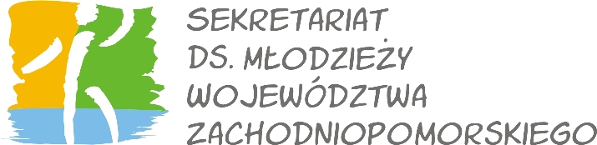
International Study Meeting „InterCoNnEcTion in Diversity”

Secretary for Youth of Westpomeranian Region, a partner in project IntercoNnEction in Diversity is looking for participants to this project from Westpomeranian Region working with Youth – both voluntary and full-time workers of intercultural youth work and interested in the educational policy “Betzavta”.

Description of the project:
The project "InterCoNnEcTion in Diversity“ is a multilateral seminar for voluntary and full-time players of intercultural youth work. The central point of the seminar is the educational policy “Betzava” and its use in intercultural contexts. In three topical modules, the bases for the concept will be put across and practical methods will be instructed, which foster a democratic cooperation and participative work with youths.

The word Betzavta describes the aim of the study meeting concept. It is about learning and understanding an equal contact with each other, in particular in a society increasingly characterized by variety. The seminar wants to sensitize the own acting in intercultural situations, in the youth work or in everyday life. Betzavta provides a remarkable approach for the creative and constructive conflict solutions in often playful exercises. Moreover, a part of the seminar will be international cooking.

Data: 1-5 March 2012
Place: Oberschleißheim near Munich, Germany

PRACTICAL INFORMATION

Participants: in the project will take part around 50 participants from Slowakia, Sweden, Italy, Spain and Poland. We are looking for 7 participants from Westpomeranian Region.

Profile of participants:
- full-time worker or volunteer responsible in his/her organisation or institution for working with young people, engaged or wanted to start intercultural youth co-operation
- interested in learning about Betzavta method;
- in the age between 18 and 50;

Costs:
- the participants do not cover the costs of accomodation, food and the seminar programme, those costs are covered by the Youth in Action Programme
- the only costs that cover the participants are: insurance during the stay abroad and travel costs to the project place - Oberschleißheim near Monachium in Germany. 70% of travel costs will be given back to the participant after the study meeting by the project leader – Bezirksjugendring – Oberbayern, so the participant covers only 30% of the travel costs at the end.

Project language: English, the project participants should know English at least in communication level.

We are waiting for the application forms until 20th of January.

